**LANGUAGE TRANSLATOR BY USING PYTHON**

**A PROJECT REPORT**

Submitted By

**Harshitha. G [192211603]**

**Nithignya. C [192211630]**

**M. Akhila [192210549]**

**In partial fulfilment for the completion of course**

**CSA0880-Python Programming for Web Applications**



**SIMATS ENGINEERING**

**THANDALAM**

**JUNE 2024**

**TABLE OF CONTENT**

|  |  |  |
| --- | --- | --- |
| **S.NO** | **TITLE** | **PAGE NO** |
| **1** | INTRODUCTION | **5** |
| **2** | RESEARCH METHODOLOGY | **8** |
| **3** | LITERATURE REVIEW | **11** |
| **4** | RESULTS | **15** |
| **5** | CONCLUSION | **24** |

***LANGUAGE TRANSLATOR BY USING PYTHON***

**ABSTRACT:**

Language translation is a critical component in bridging communication gaps across diverse linguistic landscapes. With the proliferation of digital content and global connectivity, the demand for efficient and accessible language translation tools continues to grow. In this project, we present the development of a language translator using the Python programming language. The primary aim of our project is to design and implement a flexible, user-friendly language translator that can translate text between multiple languages.

Our language translator employs fundamental text processing methodologies such as tokenization, sentence segmentation, and part-of-speech tagging to preprocess input text. We harness the power of external translation APIs, such as Google Translate API or Microsoft Translator API, to facilitate language translation seamlessly. The core functionality of the Leveraging Python's versatility and rich ecosystem of libraries, we have crafted a robust solution that integrates various natural language processing techniques and translation Language translator is encapsulated within intuitive user interfaces, enabling users to input text and select target languages effortlessly. We prioritize user experience by designing interfaces that are responsive, visually appealing, and easy to navigate. Furthermore, our language translator incorporates error handling mechanisms and validation checks to ensure reliable and accurate translation results.

We address potential challenges such as language ambiguities, cultural nuances, and text formatting discrepancies to enhance the overall translation quality. Through systematic testing and evaluation, we assess the performance and efficiency of our language translator across different language pairs and input scenarios. We benchmark translation accuracy, processing speed, and resource consumption to optimize the translator's performance and address potential bottlenecks. Looking ahead, the future of language translators lies in the convergence of human expertise and technological innovation. Hybrid approaches that combine the strengths of human translators with the scalability of machine translation systems hold promise in achieving greater accuracy, efficiency, and cultural sensitivity in translation.

**KEYWORDS:** Language Translation, Python Programming Language, Performance Evaluation,

Accessibility.

**INTRODUCTION:**

In today's interconnected world, the ability to break down language barriers is crucial for effective communication and collaboration. Language converters play a pivotal role in facilitating cross-linguistic understanding by enabling the translation of text or speech from one language to another. In this context, leveraging the power and versatility of the Python programming language, we embark on a journey to develop a sophisticated language converter. Our project aims to harness the capabilities of Python to create a robust and user-friendly language converter that empowers individuals and organizations to transcend linguistic boundaries. Python's extensive ecosystem of libraries and frameworks, coupled with its simplicity and readability, makes it an ideal choice for building language converters that are both efficient and accessible.The need for language converters spans various domains, including business, education, travel, and diplomacy.

Whether it's translating documents, conducting multilingual meetings, or engaging with global audiences, the demand for reliable language conversion tools continues to rise. By leveraging Python, we seek to address this demand by delivering a versatile and scalable solution.Our language converter will utilize cutting-edge natural language processing (NLP) techniques to analyze and translate text effectively. Through tokenization, part-of-speech tagging, and syntactic parsing, we will break down linguistic structures and extract meaningful information for translation. Additionally, we will integrate with external translation APIs, such as Google Translate or Microsoft Translator, to access vast multilingual datasets and ensure accurate translations.User experience is a key focus of our project.

We will design intuitive interfaces that allow users to input text or speech in their preferred language and seamlessly convert it into the target language of their choice. Emphasizing simplicity and usability, our interfaces will cater to diverse user needs while maintaining a high level of performance and reliability.Furthermore, our language converter will prioritize robust error handling and validation mechanisms to ensure the accuracy and consistency of translation outputs. We recognize the importance of preserving linguistic nuances and cultural context during the translation process, and our converter will strive to maintain fidelity to the original meaning while adapting to the nuances of the target language.Language translation, in its essence, is the art and science of conveying meaning from one language to another while preserving context, nuance, and cultural subtleties. It transcends mere word substitution, encapsulating the intricate interplay of language, culture, and communication dynamics. At its core, translation is a testament to human ingenuity, adaptability, and the innate desire to connect with others, regardless of linguistic boundaries.

**Motivation:**

The need to address a speech based translation system roots from the paralinguistic features such as prosody, voice and emotion of the voice speaker that is ignored in the common Text-To-Text translation systems. Our motivation rests specifically on training a system that can ideally encapsulate the aforementioned features as it translates one language to another. Moreover, the cascaded 3 step machine translation systems carry the possibility of aggravating the errors encountered with each progressing step. In contrast, the Speech-To-Speech systems are advantageous over the cascaded TT systems as they follow a one step process which requires lesser computation power and have improved inference latency. The Language translators allow computer programmers to write sets of instructions in specific programming languages. These instructions are converted by the language translator into machine code. The computer system then reads these machine code instructions and executes them.

**BENEFITS OF USING LANGUAGE TRANSLATOR :**

**1.Improved communication:** Language translators can help break down language barriers, enabling clear and effective communication between people who speak different languages. This is especially important in today's globalized world, where businesses and individuals often interact with people from different cultural backgrounds.

2.**Accessibility**: Translation devices can help break down language barriers, making it easier for people from different cultures to communicate and understand each other. This is particularly useful in business settings, where multilingual teams can collaborate more effectively.

3..**Real-time Translation:** Many translation devices offer real-time translation, allowing for immediate understanding and response during conversations.

4.**Enhancing Cultural Understanding:** Translation isn't just about converting words; it's also about conveying cultural nuances and context. Translators help promote understanding and appreciation of different cultures by accurately conveying messages across languages.

5.**Saving Time and Resources:** Instead of hiring multilingual staff or relying on manual translation methods, businesses can use language translators to save time and resources. Automated translation tools can quickly translate large volumes of text at a fraction of the cost of traditional translation services.

**Problem Faced Using Language Translators:**

Language limitations

Complex languages Compound words

Poorly written texts

Delivery Deadliness

Contextual Understanding

Language Pair Limitations

Privacy and Security Concern

Lack of Human Touch

Post-Editing Requirements

Maintenance and Updates

Ambiguity

**OBJECTIVES:**

1.**Facilitating Communication:** Language translators aim to bridge communication gaps between individuals or groups who speak different languages. By translating text or speech from one language to another, translators enable understanding and exchange of information across linguistic boundaries.

2.**Preserving Meaning:** A good language translator strives to accurately convey the meaning and intent of the original message in the target language. This involves understanding cultural nuances, idiomatic expressions, and contextual references to ensure that the translated content retains its original significance.

3.**Enabling Access:** Language translators play a crucial role in enabling access to information, services, and resources for people who may not be proficient in the language of the original content. This includes translating documents, websites, software interfaces, and multimedia content to make them accessible to diverse audiences.

4.**Promoting Multilingualism:** Language translators contribute to the promotion and preservation of multilingualism by facilitating communication and cultural exchange between speakers of different languages. They help celebrate linguistic diversity and foster mutual understanding in multicultural societies.

5.**Supporting Globalization:** In an increasingly interconnected world, language translators support globalization efforts by facilitating international trade, diplomacy, tourism, and academic exchange. They help businesses expand into new markets, facilitate cross-border collaboration, and foster international cooperation.

6.**Enhancing User Experience:** Translators aim to provide users with a seamless and intuitive experience by delivering high-quality translations that are accurate, clear, and culturally appropriate. This involves employing linguistic expertise, utilizing advanced translation technologies, and adhering to established standards and best practices.

7.**Ensuring Confidentiality:** In certain contexts, such as legal, medical, or diplomatic translation, maintaining confidentiality and privacy is paramount. Translators must adhere to professional ethics and confidentiality protocols to safeguard sensitive information and uphold the trust of their clients and stakeholders.

8.**Adapting to Technological Advances:** With the advancement of technology, language translators increasingly leverage artificial intelligence, machine learning, and natural language processing techniques to improve translation accuracy, efficiency, and scalability.

**RESEARCH METHODOLOGY:**

**1.Define the Research Objectives:** Clearly define the purpose and objectives of the research. Determine what aspects of language translators you want to investigate, such as translation accuracy, user experience, efficiency, impact on communication, etc.

1. **Literature Review:** Conduct a comprehensive review of existing literature related to language translators. Explore academic papers, books, journals, conference proceedings, and online resources to understand the current state of research, theoretical frameworks, methodologies used, key findings, and gaps in knowledge.
2. **Research Design:**
   * **Research Approach:** Determine whether your research will be qualitative, quantitative, or a combination of both**.**
   * **Sampling:** Decide on the population and sampling technique if applicable. Consider factors such as language pairs, translation domains (e.g., legal, medical, technical), and user demographics.
   * **Data Collection Methods:** Choose appropriate methods for collecting data, such as surveys, interviews, experiments, observation, document analysis, or using existing datasets.
   * **Variables and Measure:** Identify variables of interest and develop measures or instruments for collecting data. This may include translation accuracy metrics, user satisfaction scales, performance indicators, etc.
   * **Ethical Considerations:** Ensure that your research complies with ethical guidelines and protects the rights and confidentiality of participants, especially if human subjects are involved.
3. **Data Collection:**

Implement your chosen data collection methods.

* + Pilots test your instruments to identify and address any issues with reliability and validity.
  + Collect data from relevant sources, such as translators, users, stakeholders, and linguistic corpora.

1. **Data Analysis:**
   * Analyze your data using appropriate statistical or qualitative analysis techniques.
   * Interpret the findings in relation to your research objectives and hypotheses.
   * Identify patterns, trends, correlations, and relationships in the data.
2. **Discussion and Conclusion:**
   * Discuss the implications of your findings in the context of existing literature and theoretical frameworks.
   * Address limitations of the study and propose areas for future research.
   * Draw conclusions regarding the research objectives and provide recommendations for practitioners, researchers, and stakeholders.
3. **Report Writing:**
   * Write a clear and coherent research report or thesis that documents your research methodology, findings, analysis, and conclusions.
   * Follow academic conventions and formatting guidelines for presenting your research in a structured and persuasive manner.
4. **Peer Review and Feedback:**
   * Seek feedback from peers, advisors, and experts in the field to improve the quality and rigor of your research.
   * Revise and refine your research based on constructive criticism and suggestions.
5. **Objectives Definition:**
   * Clearly define the research objectives, such as understanding the effectiveness of machine translation systems, assessing the role of human translators in specific contexts, or evaluating user satisfaction with translation tools.
6. **Selection of Participants:**
   * Identify the target population or participants for the study, which may include translators, language professionals, users of translation tools, or specific user groups.

**PROPOSED SYSTEM:**

* + The aim of the proposed system is to develop a system that has capability to perform Translation, Converting text to speech, Speech Recognition. The system proposed here will be developed for a small domain of English words.
  + A translator is a programming language processor that modifies a computer program from one language to another.

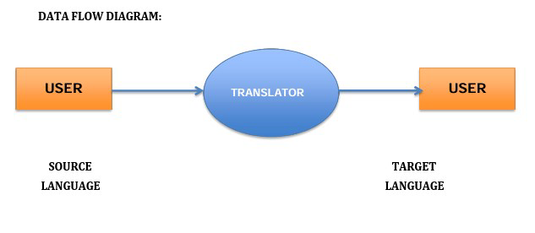

**LITERATURE SURVEY:**

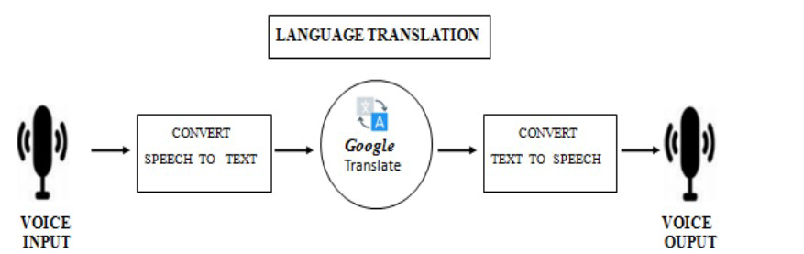

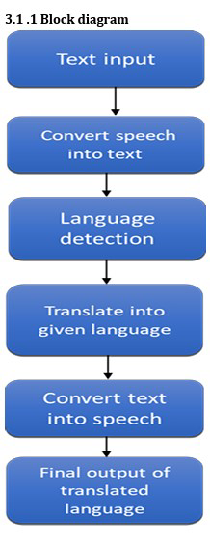

**Algorithm/Flowchart Algorithm:**

Step 1: Select the language

Step 2: Input the text/speech that want to translate

Step 3: convert the speech into text

Step 4: language detection

Step 5: translate into given language

Step 6: convert speech into text Step 7: output of translated language

**Flowchart:**

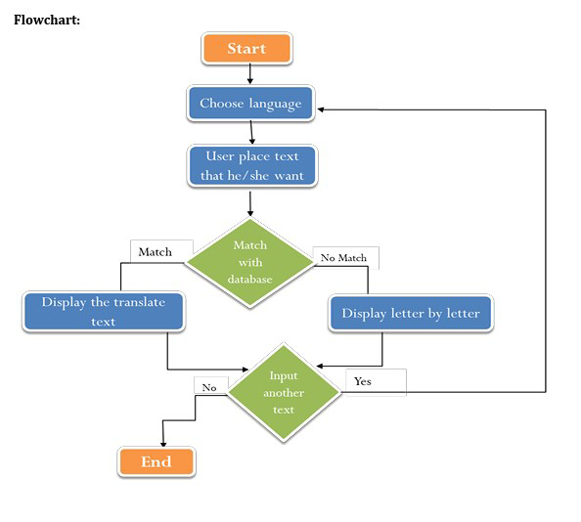

**DATASET:**

* Tkinter module as GUI interface
* Ctypes library
* PIL library (python imaging library)
* Tkinter.messagebox as tkMessageBox
* Speech recognition library
* pyttsx3 is a text-to-speech conversion library.
* Threading library
* From deep translator module import googletrans library
* Gtts module for text to audio
* pydub is a Python library with audio files.

**TECHNOLOGY:**

⚫ We Important Libraries and python modules.

⚫ Python frontend

⚫ API calls

⚫ Speech Recognition module.

⚫ Flask for GUI

⚫ We Use VS Code Software as code editor

**USER MODULE:**

⚫ Text/speak: that he/she want to translate.

⚫ Language change: According to understanding they can change language of the translation.

# RESULT AND DISCUSSION

***SOURCE CODE:***

import speech_recognition as sr

from googletrans import Translator

import gtts

import playsound

recognizer = sr.Recognizer()

with sr.Microphone() as source:

    print("Speak now")

    voice = recognizer.listen(source)

    try:

        text = recognizer.recognize_google(voice, language='en')

        print(f"Recognized Text: {text}")

    except sr.UnknownValueError:

        print("Could not understand the audio")

        text = None

    except sr.RequestError:

        print("Could not request results from Google")

        text = None

if text:

    translator = Translator()

    translation = translator.translate(text, dest='te')

    print(f"Translated Text: {translation.text}")

    converted_audio = gtts.gTTS(translation.text, lang="te")

    converted_audio.save("hello.mp3")

    playsound.playsound("hello.mp3")

**figure 1:** Project Architecture for Language convertor using python

As soon as we compile the code "**speak now**" message appears on screen

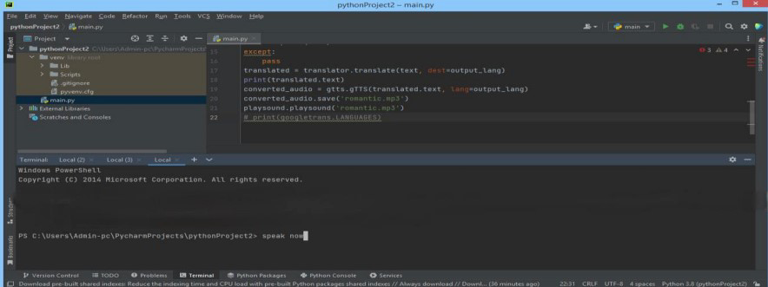

**Screenshot 1**: Display Screen for language convertor using python

After "**speak now**" message appears, we need to speak something of any language(say english) and it will appear on screen

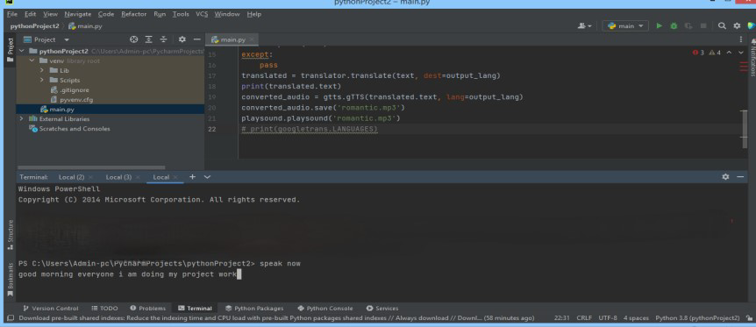

**Screenshot 2:** Input Screen for language converter using python Now that english text will be converted into text of another language preferred by the user (say hindi) and it will be displayed on screen and audio of output text will be played.

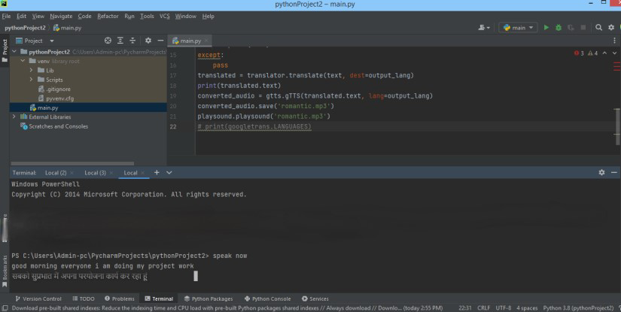

**Screenshot 3:** Output screen for language convertor using python **figure 1: Language Most used for Language Translators in recent times**

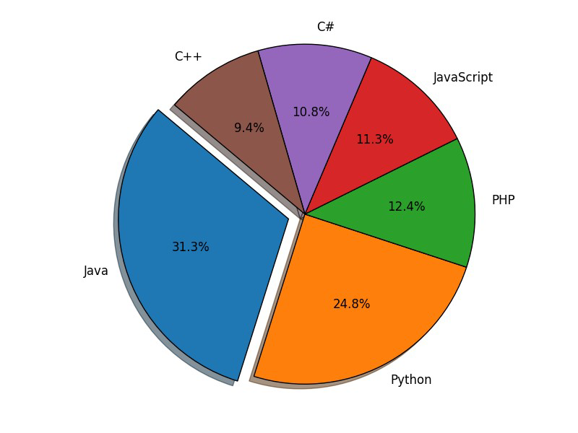

**How Language Translators Works on Various Languages:**



**Speak Your Language -> Re-use every word you Translate.**

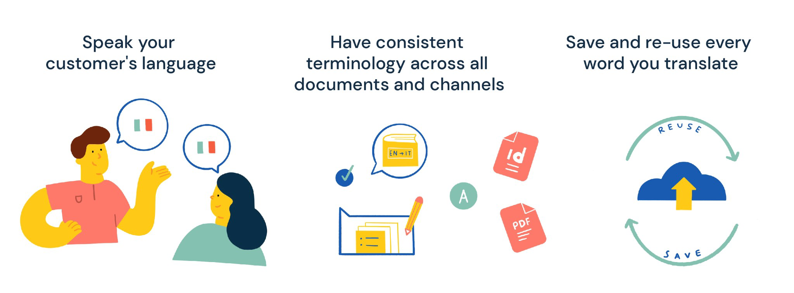

**FUTURE SCOPE OF LANGUAGE TRANSLATOR:**

1. **Machine Learning and AI Advancements**: Machine learning and artificial intelligence are continually evolving, leading to more sophisticated translation models. Future translation systems are likely to become more accurate, context-aware, and capable of handling nuanced language nuances.
2. **Neural Machine Translation (NMT):** Neural machine translation has already shown significant improvements in translation quality compared to previous statistical methods. Future developments in NMT could lead to even more accurate and natural translations across various languages.
3. **Multimodal Translation**: With the rise of multimedia content on the internet, there's a growing need for translation systems capable of handling various types of data, including text, images, audio, and video. Future translation technologies may integrate multiple modalities to provide comprehensive translation solutions.
4. **Real-time Translation:** Real-time translation systems, which enable seamless communication between individuals speaking different languages, hold great potential. Future advancements may lead to more efficient and accurate real-time translation tools for both spoken and written communication.
5. **Personalized Translation:** As AI technologies become more sophisticated, translation systems could become increasingly personalized, adapting to individual user preferences, language proficiency levels, and specific contexts.
6. **Integration with IoT and Wearable Devices:** With the proliferation of IoT devices and wearable technology, translation services could be seamlessly integrated into various devices, allowing for instant translation in different settings such as travel, business meetings, and healthcare.
7. **Translation for Low-Resource Languages:** Efforts are being made to improve translation capabilities for low-resource languages that have limited linguistic data available. Future advancements may focus on developing robust translation models for these languages to promote inclusivity and accessibility.
8. **Ethical and Cultural Considerations**: As translation technologies become more pervasive, there's a growing need to address ethical and cultural considerations related to language translation, including issues such as bias, privacy, and cultural sensitivity.

However to make this system more precise and useful for a wide range of target audience, it demands some further improvements Further we are aiming at following improvements:

To take input text from an image of printed English text by implementing character recognition. Presently we are only able to take manual input through a virtual keyboard. The system can be further extended to include more languages and possibly dialects.

**CONCLUSION:**

In conclusion, the future of language translation holds immense promise and potential. Advancements in machine learning, neural networks, and artificial intelligence are driving the development of more accurate, context-aware translation systems. These systems are not only becoming more proficient in translating text but also expanding to include multimodal translation for images, audio, and video.Real-time translation capabilities are enhancing cross-cultural communication, while personalized translation services cater to individual preferences and language proficiency levels. Integration with IoT devices and wearable technology is making translation more accessible and convenient in various contexts.Moreover, efforts to address ethical and cultural considerations in translation underscore the importance of creating inclusive and respectful language solutions. As translation technologies continue to evolve, there's a growing emphasis on promoting diversity, preserving linguistic heritage, and fostering global understanding.Overall, the future of language translation is characterized by innovation, inclusivity, and the democratization of communication across linguistic boundaries. As these technologies advance, they have the potential to profoundly impact how we interact, collaborate, and connect in an increasingly interconnected world.

In this proposed system, we implemented the system for users who are

having language barriers and also its user interface is also user friendly so that users can easily interact with this system . so it automatically reduces the user task for understanding the languages for communication. Translation is not merely at changing words, but also transferring cultural equivalence with the culture of the original language and the recipient of that language as well as possible. The better translation must be accepted by all people in logic and based on fact; thus, the message which is contained in the source language (SL) can satisfy the target language (TL) reader with the information within. When you understand the importance of translation for everyone, you will be able to see it as a necessary and worthy investment.

**REFERENCES:**

* [Kelly,](http://paperpile.com/b/iHd9n9/Hgkf) [Nataly,](http://paperpile.com/b/iHd9n9/Hgkf) [and](http://paperpile.com/b/iHd9n9/Hgkf) [Jost](http://paperpile.com/b/iHd9n9/Hgkf) [Zetzsche.](http://paperpile.com/b/iHd9n9/Hgkf) [2012.](http://paperpile.com/b/iHd9n9/Hgkf) [*Found*](http://paperpile.com/b/iHd9n9/Hgkf)[*in*](http://paperpile.com/b/iHd9n9/Hgkf)[*Translation:*](http://paperpile.com/b/iHd9n9/Hgkf)[*How Language*](http://paperpile.com/b/iHd9n9/Hgkf)[*Shapes*](http://paperpile.com/b/iHd9n9/Hgkf)[*Our*](http://paperpile.com/b/iHd9n9/Hgkf)[*Lives*](http://paperpile.com/b/iHd9n9/Hgkf)[*and*](http://paperpile.com/b/iHd9n9/Hgkf)[*Transforms*](http://paperpile.com/b/iHd9n9/Hgkf)[*the*](http://paperpile.com/b/iHd9n9/Hgkf)[*World*.](http://paperpile.com/b/iHd9n9/Hgkf) [Penguin.](http://paperpile.com/b/iHd9n9/Hgkf)
* [Makwana,](http://paperpile.com/b/iHd9n9/Niok) [Vyom,](http://paperpile.com/b/iHd9n9/Niok) [Keyur](http://paperpile.com/b/iHd9n9/Niok) [Babariya,](http://paperpile.com/b/iHd9n9/Niok) [and](http://paperpile.com/b/iHd9n9/Niok) [Vishakha](http://paperpile.com/b/iHd9n9/Niok) [Shelke.](http://paperpile.com/b/iHd9n9/Niok) [2021.](http://paperpile.com/b/iHd9n9/Niok) [*Thing*](http://paperpile.com/b/iHd9n9/Niok)

[*Translator:*](http://paperpile.com/b/iHd9n9/Niok)[*An*](http://paperpile.com/b/iHd9n9/Niok)[*Efficient*](http://paperpile.com/b/iHd9n9/Niok)[*Way*](http://paperpile.com/b/iHd9n9/Niok)[*to*](http://paperpile.com/b/iHd9n9/Niok)[*Classify*](http://paperpile.com/b/iHd9n9/Niok)[*Different*](http://paperpile.com/b/iHd9n9/Niok)[*Things*.](http://paperpile.com/b/iHd9n9/Niok) [Eliva](http://paperpile.com/b/iHd9n9/Niok) [Press.](http://paperpile.com/b/iHd9n9/Niok)

* [Rayner,](http://paperpile.com/b/iHd9n9/bccp) [Manny.](http://paperpile.com/b/iHd9n9/bccp) [2000.](http://paperpile.com/b/iHd9n9/bccp) [*The*](http://paperpile.com/b/iHd9n9/bccp)[*Spoken*](http://paperpile.com/b/iHd9n9/bccp)[*Language*](http://paperpile.com/b/iHd9n9/bccp)[*Translator*.](http://paperpile.com/b/iHd9n9/bccp) [Cambridge University](http://paperpile.com/b/iHd9n9/bccp) [Press.](http://paperpile.com/b/iHd9n9/bccp)
* [Robinson,](http://paperpile.com/b/iHd9n9/egma) [Douglas.](http://paperpile.com/b/iHd9n9/egma) [2012.](http://paperpile.com/b/iHd9n9/egma) [*Becoming*](http://paperpile.com/b/iHd9n9/egma)[*a*](http://paperpile.com/b/iHd9n9/egma)[*Translator:*](http://paperpile.com/b/iHd9n9/egma)[*An*](http://paperpile.com/b/iHd9n9/egma)[*Introduction*](http://paperpile.com/b/iHd9n9/egma)[*to*](http://paperpile.com/b/iHd9n9/egma)[*the Theory*](http://paperpile.com/b/iHd9n9/egma)[*and*](http://paperpile.com/b/iHd9n9/egma)[*Practice*](http://paperpile.com/b/iHd9n9/egma)[*of*](http://paperpile.com/b/iHd9n9/egma)[*Translation*.](http://paperpile.com/b/iHd9n9/egma) [Routledge.](http://paperpile.com/b/iHd9n9/egma)
* [Sprung,](http://paperpile.com/b/iHd9n9/CfP4) [Robert](http://paperpile.com/b/iHd9n9/CfP4) [C.,](http://paperpile.com/b/iHd9n9/CfP4) [and](http://paperpile.com/b/iHd9n9/CfP4) [Simone](http://paperpile.com/b/iHd9n9/CfP4) [Jaroniec.](http://paperpile.com/b/iHd9n9/CfP4) [2000.](http://paperpile.com/b/iHd9n9/CfP4) [*Translating*](http://paperpile.com/b/iHd9n9/CfP4)[*Into*](http://paperpile.com/b/iHd9n9/CfP4)[*Success: Cutting-Edge*](http://paperpile.com/b/iHd9n9/CfP4)[*Strategies*](http://paperpile.com/b/iHd9n9/CfP4)[*for*](http://paperpile.com/b/iHd9n9/CfP4)[*Going*](http://paperpile.com/b/iHd9n9/CfP4)[*Multilingual*](http://paperpile.com/b/iHd9n9/CfP4)[*in*](http://paperpile.com/b/iHd9n9/CfP4)[*a*](http://paperpile.com/b/iHd9n9/CfP4)[*Global*](http://paperpile.com/b/iHd9n9/CfP4)[*Age*.](http://paperpile.com/b/iHd9n9/CfP4) [John Benjamins](http://paperpile.com/b/iHd9n9/CfP4) [Publishing.](http://paperpile.com/b/iHd9n9/CfP4)
* [Venuti,](http://paperpile.com/b/iHd9n9/bswL) [Lawrence.](http://paperpile.com/b/iHd9n9/bswL) [2012.](http://paperpile.com/b/iHd9n9/bswL) [*The*](http://paperpile.com/b/iHd9n9/bswL)[*Translator’s*](http://paperpile.com/b/iHd9n9/bswL)[*Invisibility:*](http://paperpile.com/b/iHd9n9/bswL)[*A*](http://paperpile.com/b/iHd9n9/bswL)[*History*](http://paperpile.com/b/iHd9n9/bswL)[*of Translation*.](http://paperpile.com/b/iHd9n9/bswL) [Routledge.](http://paperpile.com/b/iHd9n9/bswL)
* Sireesh Hang Limbu, “Direct Speech to Speech Translation Using Machine

Learning”, December 2020

* S. Venkateswarlu, D. B. K. Kamesh , J. K. R. Sastry and Radhika Rani, “

Text to Speech Conversion”, 23 September 2020

* Chris Piech, Sami Abu-El-Haija, “Auto-Translation for Localized

Instruction”, Sep 2019

* Sagar Patil, Mayuri Phonde, Siddharth Prajapati , “Multilingual Speech and

Text Recognition and Translation using Image”, April-2020